**DATABASE SYSTEM LAB # 9**

**Name: Ahmed Kasteer**

**Section: 4D**

**Roll Number: 20F-0336**

**Question 1**

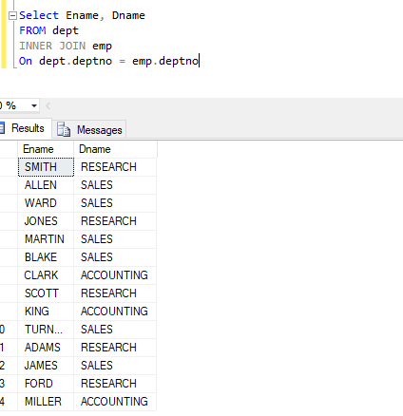

**Question 2:**

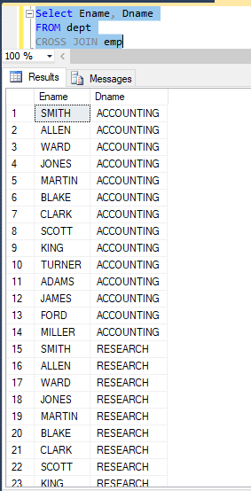

**Question 3:**

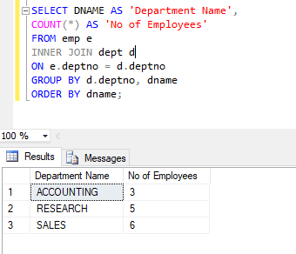

**Question4:**

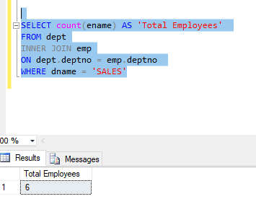

**Question 5:**

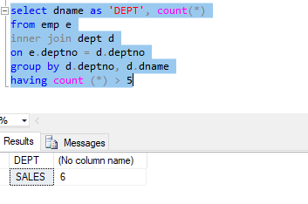

**Question 6:**

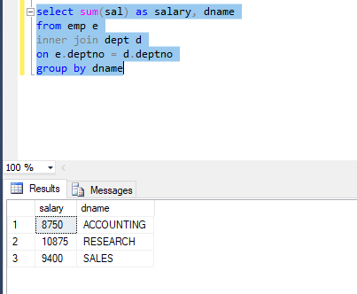

**Question 7:**

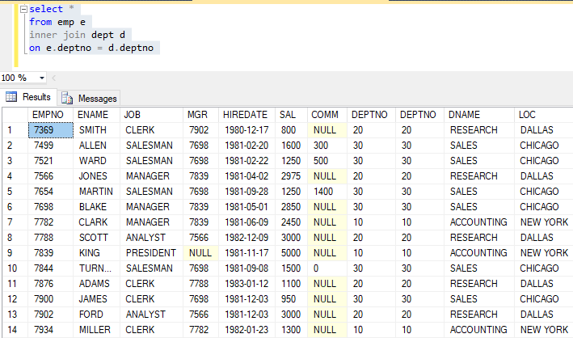

**Question 8:**

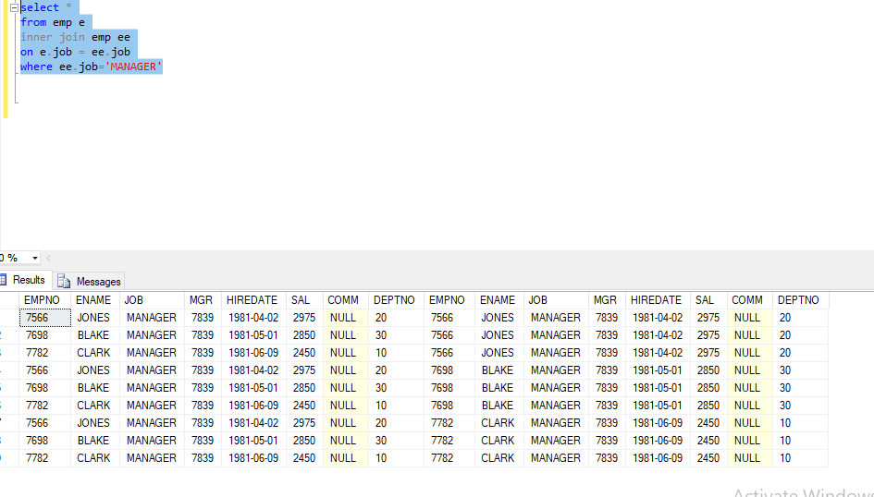

**Question 9:**

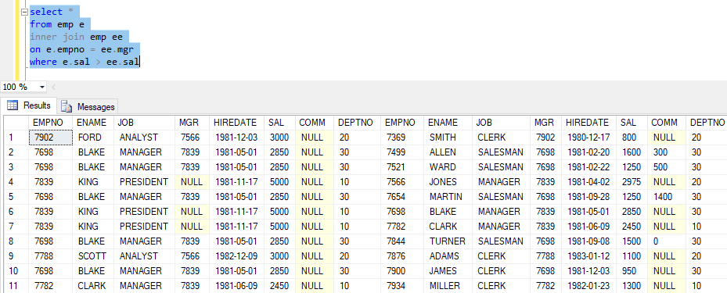

**Question 10:**

